**Project Design Phase-I**

**Solution Architecture**

|  |  |
| --- | --- |
| Date |  |
| Team ID | PNT2022TMID42624 |
| Project Name | Project - University Admit Eligibility Predictor |
| Maximum Marks | 4 Marks |

**Architecture Diagram:**

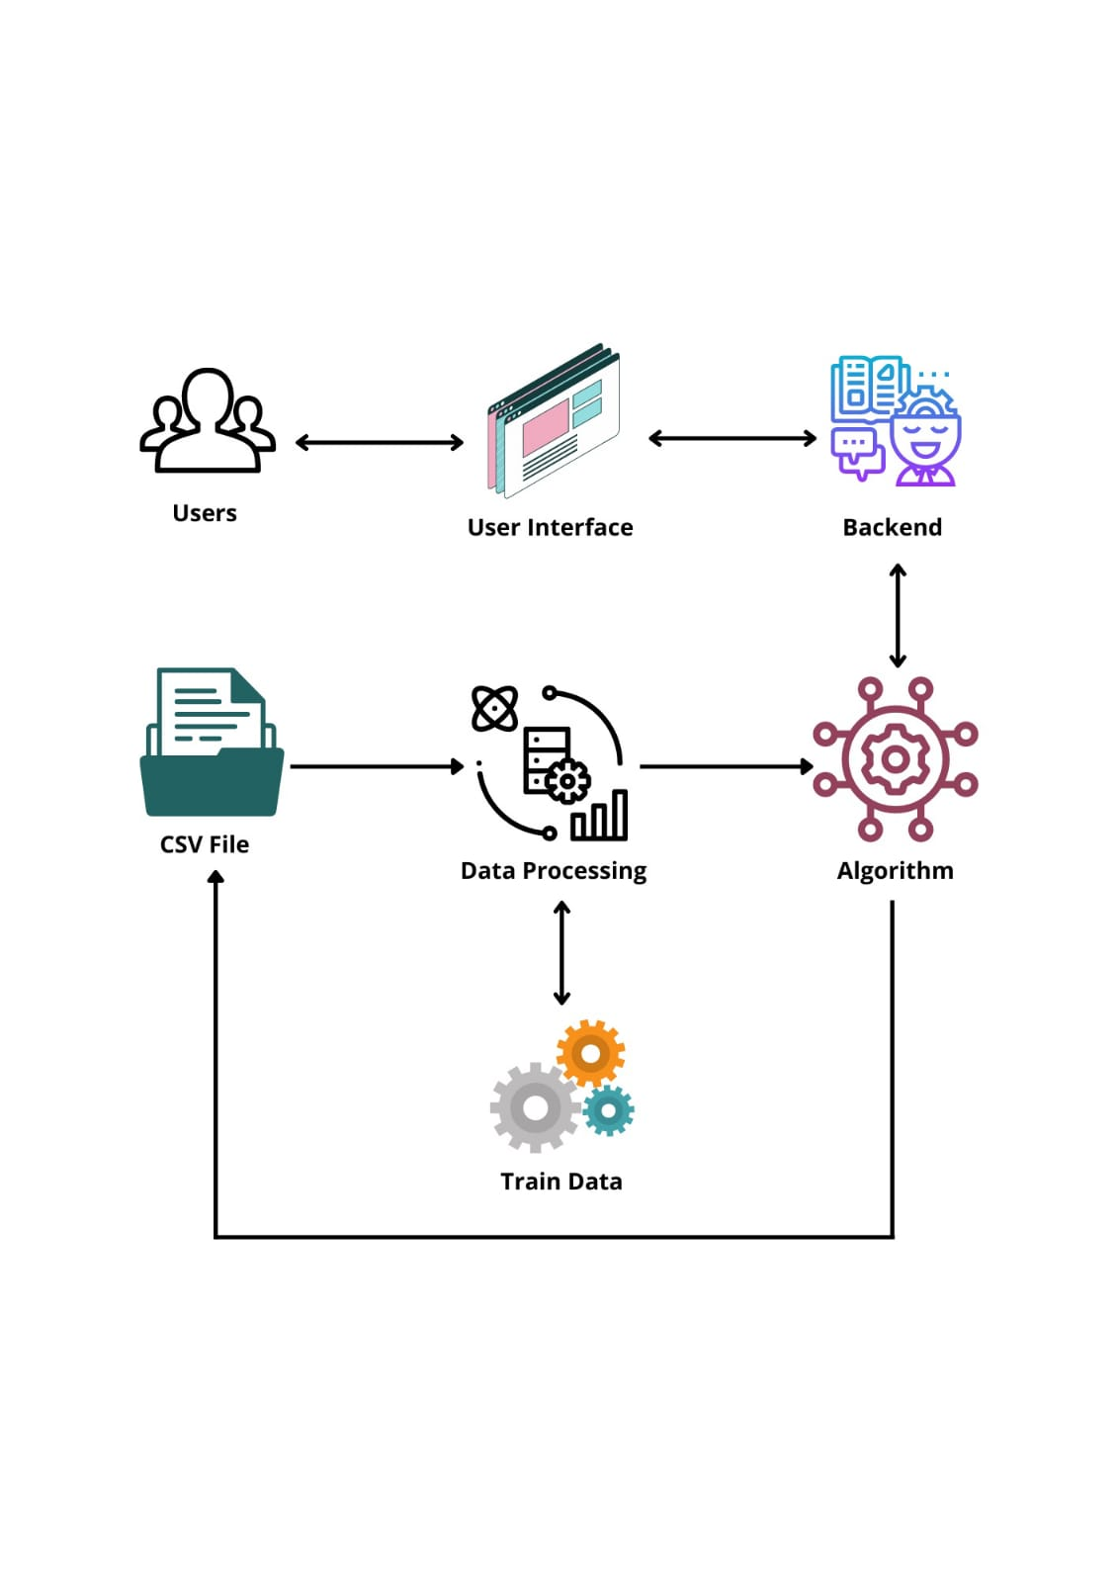**Solution** **Architecture Diagram:**

* Students are often worried about their chances of admission to University.
* The aim of this project is to help students in shortlisting universities with their profiles.
* The predicted output gives them a fair idea about their admission chances to a particular university.
* This analysis should also help students who are currently preparing or will be preparing to get a better idea.